8757D-01
S E R V I C E N O T E

Supersedes:
None

8757D

Serial Numbers: Unknown (see text) / S/N MY46060400

The 8757D logger boards (A7-A10; P/N 08757-60146) have a reference diode that has excessive temperature drift. This may cause the dynamic accuracy test (as measured by the 11613A/B) to fail if the temperature has drifted from that at which it was originally adjusted.

To Be Performed By: Agilent-Qualified Personnel or Customer

Parts Required:
P/N Description Qty.
1902-3512 6.2v Zener Diode 1 per logger board (3 or 4 per instrument)
Wire 26-30 AWG ~20 inches (50cm) most any insulated wire will work
0470-0634 Quick setting epoxy

Situation:
When the 8757D logger board was changed to use surface mount parts (sometime around 2003), a 6.2v reference zener diode (VR3) was used that did not meet the required temperature drift specification. This will cause the 8757D to possibly fail its dynamic accuracy test as measured with the 11613A/B. Typically it may fail if the temperature drifts by more than 2 degrees from that used on its original calibration. The 8757D should meet its specification over a full 10 degree range (20-30deg C). While this will cause the dynamic accuracy test to fail, the customer’s end result measurement will most likely not be affected significantly. This is because the added error due to the temperature drift is typically under 0.1 dB while the detector specification is 0.4 dB or more. In addition, other scalar uncertainties, such as mismatch errors, will push the total measurement uncertainty to about +/- 1-2 dB. As a result, the 0.1 dB increase in error is probably negligible.

Solution/Action:
Each logger board that used surface mount parts (08757-60146) should have its reference diode (VR3) replaced with a more stable version. The stable diode is a through-hole part (1902-3512.) This board has been redesigned to use this new part. The new board will have a different part number. All units made since December 2007 have either been modified at the factory, or have the newer logger assembly installed.

If an unmodified logger board is found, the Zener diode VR3 should be removed (see figure 1.) The new Zener diode should be connected to the same location via two wires. Once properly soldered, it should be epoxied in place using quick-setting (5 minute) epoxy. Make sure that polarity is observed. See figure 2 for placement. Allow time to cure. Once the instrument has been reassembled and warmed up, perform the logger calibration using the 11613A/B calibrator.

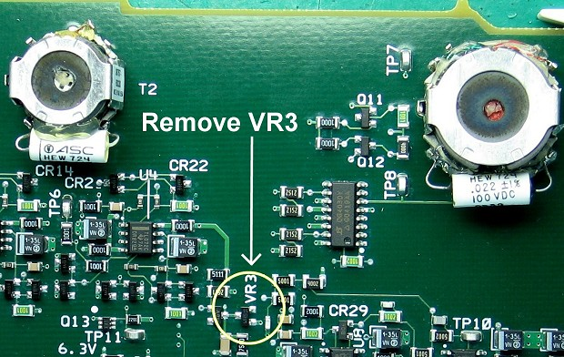

Figure 1. Locate and remove VR3

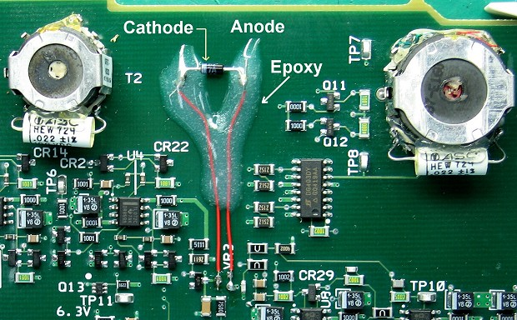

Figure 2. Solder the new diode where VR3 was located using two short lengths of wire. Note that the two board contacts on the right side of VR3 (Anode-side) are electrically connected, so you can solder to either one or both. Epoxy leads to board as shown. Allow to cure.

Note: For best results, the software used to test and adjust the 8757 should be updated to revision 4.11 or later. This is available at: http://na.tm.agilent.com/8757

